Minor Project

On

**service Robot**

Team coordinators

Shubham Sharma 10216210031

Simranjeet Singh 10216210059



Under the supervision of

Prof. MR. Mandeep

(Mechanical department)

SRM University, Delhi-NCR, Sonipat

**CERTIFICATE**

This is to certify that minor project report on “**SERVICE ROBOT” which** is submitted by Shubham Sharma and Simranjeet singh in partial fulfilment of the requirement for the degree of B.Tech in department of Mechanical Engineering of SRM University , is a record of his own work carried out under under MR. Mandeep supervision .

EXTERNAL EXAMINER Ass Prof. Mr. Mandeep

(project guide)

**Acknowledgement**

I express my sincere thanks to prof. Mr Mandeep (Assistant professor, dept of Mechanical Engineering), my project in charge, who guided me through the project also gave valuable suggestions and guidance for completing the project. he helped me to understand the intricate issues involved in project-making besides effectively presenting it. These intricacies would have been lost otherwise .my project has been a success only of his guidance.

We are highly grateful to Prof.N.K. Sharma (HOD, dept of mechanical engineering) for providing us their valuable, suggestions, motivation and ideas during project work. We are also thankful to the whole mechanical department for providing us the technical support to carry out the project work, to let us utilize all the necessary facilities of the institute at each & every step during the project work.

**Abstract**

Service robot, it works on a principle where it converts electrical signal into mechanical energy, Radio-controlled robot uses a common set of components for its control and operation, it requires a transmitter, which has the control, and a receiver which sits inside the robot, the receiver changes the radio signal broadcast from the transmitter into suitable electrical control signals for the other components of the control system,

it goes to Arduino Uno to make it compile the pre uploaded programme, then signal goes to L293D motor drivers, 1st motor driver to control the motors in the tyres because a direct current, or DC, motor is the most common type of motor. DC motors normally have just two leads, one positive and one negative. If you connect these two leads directly to a battery, the motor will rotate. If you switch the leads, the motor will rotate in the opposite direction.

To control the direction of the spin of DC motor, without changing the way that the leads are connected, you can use a circuit called an H-Bridge. An H bridge is an electronic circuit that can drive the motor in both directions, and 2nd motor driver for the motor in the neck of the robot.

This is can be used in restaurants for serving dishes and can reduce labour cost.

And use for material material handling in domestic areas.

**Contents**

S.No page no

**1**. **Introduction 8**

1.1 reason for opting this project 8

1.2 what does it do 9

**2. Literature survey 10**

2.1 brief history 10

2.2 principle 11

2.3 merits and demerits 12

2.4 Applications 12

**3. components 13**

3.1 Arduino Uno 13

3.2 RF module 14

3.3 DC motor 14

3.4 L293D motor driver 15

3.5 brackets and nut & bolt 15

**4. Experimental work 16**

4.1 Design 16

4.2 base 17

4.3 electronic circuit 17

4.4 fabrication 18

**5 conclusions 19**

**6refrences 20**

**7 cost estimation** **21**

**List of figures**

Figure no Figure page no

1 Mechatronic system 8

2 Arduino Uno 11

3 RF module 12

4 L293D pin diagram 13

5 project design 14

6 base 15

7 circuit diagram 15

8 fabricated model 16

**Abbreviations**

I/O -> input/output

V -> voltage

MHz -> mega hertz

I/P -> input

O/P -> output

Amp -> ampere

IC -> integrated circuit

**Introduction**

**REASONS FOR OPTING THIS PROJECT**

•There is a restaurant named “Robot restaurant” in Bengaluru where the servants are robots, from there we got the idea to make something like that.

•Robots in today’s growing world are becoming more important to humans as to save time and increase accuracy.

•Today, every industry, large factories have automated guided vehicles or robotic arms.

•A Robot can continuously work on a particular thing giving the uniform output every single time without errors according to the programme uploaded or command given to it.

•We can also edit or change the programme or command according to our needs.

•Robots can also do multifunction the tasks in minimum time.

•This project can be substituted by any servant at restaurants, shops, homes, or any place where servants are required to convey things/food/water/etc.

•This servant robot reduces human errors by not dropping things while conveying.

•This is very efficient in the long run as compared to the salary given to servants.

•It does not give excuses or take day offs.

•Works on your fingertips.

•One of the major reasons for choosing this project was high future scope in mechatronics,

And an augmentation in the demand of automated vehicles , automatic delivering robots which works on many different aspects.

**WHAT DOES IT DO**

•This is a robotic servant who conveys food if in restaurant, different objects if in shop, water, food or anything we need if at home.

•The person controlling this robot can see what this robot is seeing simply by revolving its neck (by remote control).

•It has a range of 30-40 meters, which is enough for restaurants, homes, shops.

•Being a prototype, it can carry a weight of maximum 4kgs.

**Literature survey**

**Brief history**

Mechatronics which is also called mechatronic engineering is a multidisciplinary branch of engineering that focuses on the engineering of both electrical and mechanical systems and also includes combination of robotics, electronics, system, control. Originally the field of mechatronics was intended to be nothing more than a combination of mechanics and electronics.A mechatronics engineer unites the principle of mechanics, electronics and computing to generate a simpler more economical and reliable system.

And there’s first robot restaurant opened in Bengaluru the first restaurant where food service is done by robots the restaurant have a team of six servant robots and the food service is done by the robots

A domestic robot is a type of service robot, an autonomous robot that is primarily used for household chores, but may also be used for education, entertainment or therapy according to their order The term "service robot" does not have a strict technical definition. The International Organization for Standardization defines a “service robot” as a robot “that performs useful tasks for humans or equipment excluding industrial automation applications”.

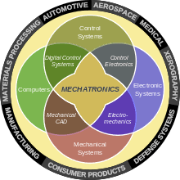

Another prototype of the domestic robot was called “Topo”, which was designed by Androbot Inc. and released in 1983. Its programming language allowed it to do geometric movements and perform tasks. However, it did not have a sensor so it could not receive the order and responded to the order correctly and thus it could not be considered as a real robot. To solve this problem, the second and third generation contained an infrared transmitter and could be controlled by a remote pad. For the last generation, Topo4 was featured by a text-to-speech processor. Although Topo4 was made, but it never went into production.

With these two prototypes of the domestic robot, the domestic robots became more and more accessible and affordable.

**Principle**

Electrical energy is converting into mechanical energy

Radio control devices use a common set of components for their control and operation. All system require a transmitter and The receiver changes the radio signal broadcast from the transmitter into suitable electrical control signals, A direct current, or DC, motor is the most common type of motor. DC motors normally have just two leads, one positive and one negative. If you connect these two leads directly to a battery, the motor will rotate. If you switch the leads, the motor will rotate in the opposite direction.control the direction of the spin of DC motor, without changing the way that the leads are connected, you can use a circuit called an H-Bridge. An H bridge is an electronic circuit that can drive the motor in both directions L298 can control the speed and direction of DC motors and and can control two motors simultaneously.

**Merits and Demerits**

MERITS

•This service robot reduces human errors by not dropping things while conveying.

•This is very efficient in the long run as compared to the salary given to servants.

•It does not give excuses or take day offs.

•Works on your fingertips.

DEMERITS

•This robot has a limited range that is of 30-40m.

•This robot can lift upto 3kg.

**APPLICATIONS**

•This project can be substituted by any servant at restaurants, shops, homes, or any place where servants are required to convey things/food/water/etc.

•This servant robot reduces human errors by not dropping things while conveying.

•This is very efficient in the long run as compared to the salary given to servants.

**Components**

**Arduino Uno**

An Introduction to Arduino Uno. It is a microcontroller board developed by Arduino.cc and based on Atmega328.

Electronic devices are becoming compact, flexible and cheap that are capable of doing more function as compared to their predecessors that happened to cover more space, turned out costly with the ability to perform fewer functions.

Experts always strive to introduce innovation in automation that requires minimum effort and gives maximum output. The microcontroller was introduced in the electronics industry with the purpose of making our tasks easy that come with even a remote connection with automation in any way. Microcontrollers are widely used in embedded systems and make devices work according to our needs and requirements.

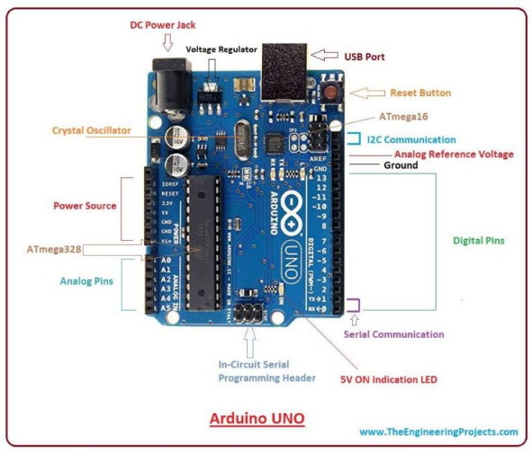Arduino Uno is a very valuable addition in the electronics that consists of USB interface, 14 digital I/O pins, 6 analog pins, and Atmega328 microcontroller Arduino Uno These pins provide the flexibility and ease of use to the external devices that can be connected through these pins. There is no hard and fast interface required to connect the devices to the board. Simply plug the external device into the pins of the board that are laid out on the board in the form of the header. Only 5 V is required to turn the board on, which can be achieved directly using USB port or external adopter, however, it can support external power source up to 12 V which can be regulated and limit to 5 V or 3.3 V based on the requirement of the project.

Figure :2

**RF Transmitter and Receiver**

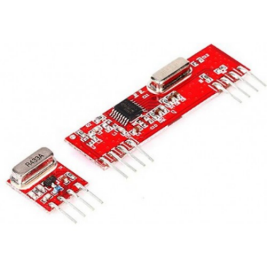 An RF module (short for radio-frequency module) is a (usually) small electronic device used to transmit and/or receive radio signals between two devices. In an embedded system it is often desirable to communicate with another device wirelessly. This wireless communication may be accomplished through optical communication or through radio-frequency (RF) communication. For many applications the medium of choice is RF since it does not require line of sight. RF communications incorporate a transmitter and a receiver. They are of various types and ranges. Some can transmit up to 500 feet. RF modules are widely used in electronic design owing to the difficulty of designing radio circuitry. Good electronic radio design is notoriously complex because of the sensitivity of radio circuits and the accuracy of components and layouts required to achieve operation on a specific frequency. The 433MHz wireless module is one of the cheap and easy to use modules for all wireless projects. These modules can be used only in pairs and only simplex communication is possible. Meaning the transmitter can only transmit information and the receiver can only receive it, so you can only send data from point A to B and not from B to A. The module could cover a minimum of 3 meters and with proper antenna a power supplies it can reach upto 100 meters theoretically. But practically we can hardly get about 30-35 meters in a normal test conditions.

Figure: 3

**DC Motor**

A **DC motor** is any of a class of rotary electrical machines that converts direct current electrical energy into mechanical energy. The most common types rely on the forces produced by magnetic fields. Nearly all types of DC motors have some internal mechanism, either electromechanical or electronic, to periodically change the direction of current flow in part of the motor.

**L293D Motor Driver**

L293D is a typical Motor driver or Motor Driver IC which allows DC motor to drive on either direction. L293D is a 16-pin IC which can control a set of two DC motors simultaneously in any direction. It means that you can control two DC motor with a single L293D IC.

It works on the concept of H-bridge. H-bridge is a circuit which allows the voltage to be flown in either direction. As you know voltage need to change its direction for being able to rotate the motor in clockwise or anticlockwise direction, Hence H-bridge IC are ideal for driving a DC motor.

In a single L293D chip there are two h-Bridge circuit inside the IC which can rotate two dc motor independently. Due its size it is very much used in robotic application for controlling DC motors. Given below is the pin diagram of a L293D motor controller.

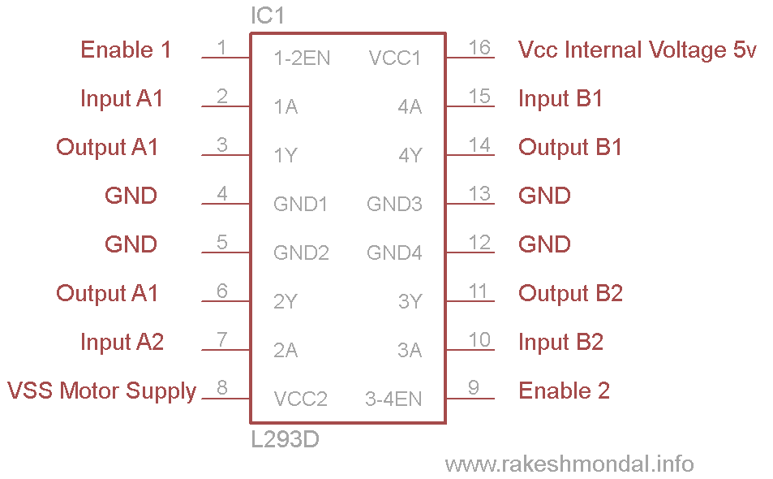There are two Enable pins on l293d. Pin 1 and pin 9, for being able to drive the motor, the pin 1 and 9 need to be high. For driving the motor with left H-bridge you need to enable pin 1 to high. And for right H-Bridge you need to make the pin 9 to high. If anyone of the either pin1 or pin9 goes low then the motor in the corresponding section will suspend working. It’s like a switch.

Figure :4

**Brackets**

Bracket is used to hold to the motor with wooden board with the help of screws.

**Nut and Bolt**

Nut and bolt are used to connect base with body of the robot.

**Experimental work**

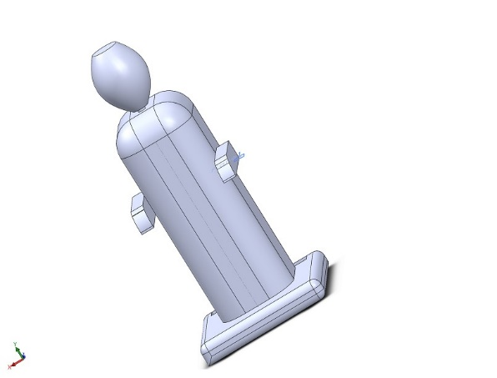**Aim**: working model of service robot.

**Procedure:**

**1. Design**

First, we designed the robot prototype in solid works so that we get a visual idea of the model

Figure :5

2. **base**

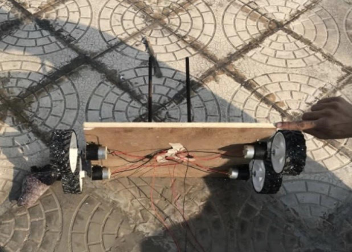a wooden plank was cut after taking proper dimensions then 4 brackets were installed on the wooden plank then 4 motors were installed in the brackets and tyres were connected to the motors after that 2 holes were made in the exact centre of the board taking proper distance in between, then 2 bolts are installed in those holes so that those bolts can support the structure

figure :6

**3. Circuit:**

Firstly transmitter (remote control) will send signal to the receiver. Then the receiver will transmit signal or I/P to Arduino Uno. Then the code that is preloaded to the Arduino will compile. And it will send the O/P to the l293D motor driver. Motor driver then will control the rotation of the motors according to the signal transmitted. Then the motors will rotate the 100mm tyres and neck rotation. The source of electricity is 12V battery and 5 amp.

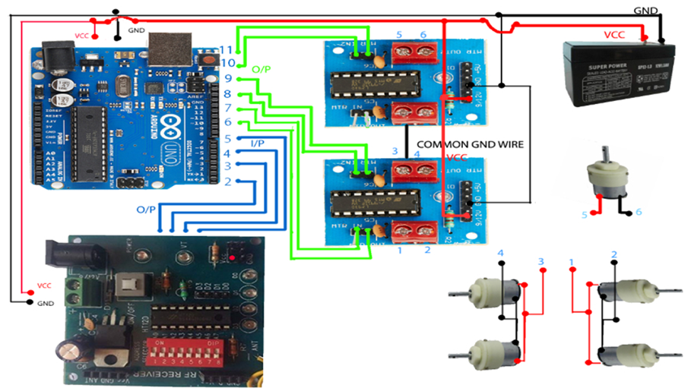

Figure:7

**4. Fabrication**

we purchased a full sized good quality Thermacol with close gaps between the particles of Thermacol , we chose Thermacol so that the weight of the robot should be less so that it can move with proper speed , after that we cut out the base from the Thermacol for the robot , on the other side of the Thermacol block we made a slot so that the wooden board setup should fit in and the same 2 holes were made on the Thermacol block and then those two nuts were passed through those holes also, finally the corners of the Thermacol were filleted by sand paper, our base was finally completed after this step.

Then after taking proper dimensions we cut out and trimmed and made the torso(mid part) of the body then in the lower back area a section was cut out for the battery (this area was chosen after keeping in mind the connectivity, and the centre of mass of the robot so that it do not fall) then a passage is made from the top of the torso to the battery chamber so that the motor of the neck of the robot gets connected to the battery now 2 hands are cut out of the Thermacol block and with the hot glue gun pasted on the sides of the torso in a way that our robot can easily hold and deliver the objects placing on the tray now all the corners are filleted and completing the mid part of the body.

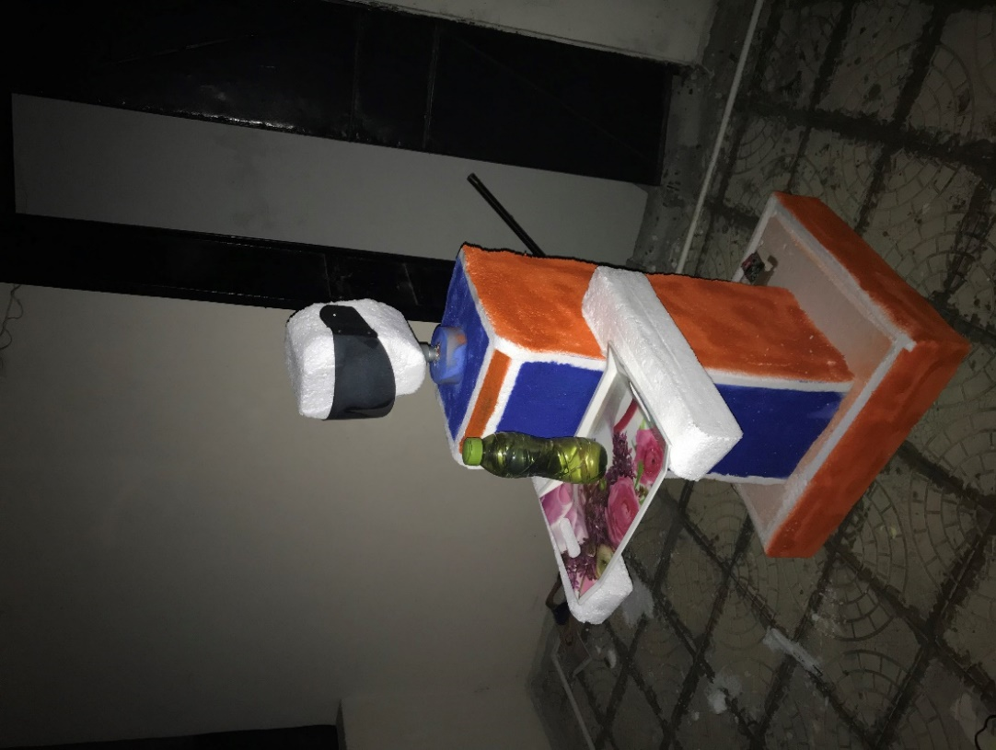Now Coming to the topmost part that is head and the neck of the robot, so a 3.5 rpm motor is installed on the (top)opening of the torso that motor is for the movement of the neck then after that a square is cut out of the Thermacol block and properly rubbed and filleted transforming the square block into an face shaped oval, then a compartment is made in the eye area of the face where the camera is to be fixed so that controller can see the view of what is our robot is seeing, camera is covered with visor to make it more attractive and giving a layer of protection to the camera also.

Now spray paints for Thermacol (as not every spray paint is suitable for the Thermacol) Were bought and robot was painted to make it more appealing.

Figure :8

**conclusion**

we concluded that it works on a principle where it converts electrical signal into

mechanical energy receiver changes the radio signal broadcast from the transmitter into

suitable electrical control signals which can we further convert to the mechanical energy

and use the robot in various places.

result:

it has a range of 30 m

it can take load up to 3,4kg (because it’s prototype)

Problems occurred:

• Wrong placing IC

•3 times bursting of IC L293D because of wrong connection

•Unbalancing of structure

**Reference**

[www.wikipedia.org](http://www.wikipedia.org) (components)

[www.includehelp.com](http://www.includehelp.com) (l293D)

[www.arduino.cc](http://www.arduino.cc) (Arduino)

[www.magatrol.com](http://www.magatrol.com)

procurement of material : from Chandni chownk

**Cost of Estimation**

|  |  |  |  |
| --- | --- | --- | --- |
| S.NO | QUANTITY | MATERIAL | COST(rupees) |
| 1 | 4 | brackets | 100 |
| 2 | 4 | Dc motor (60rpm) | 500 |
| 3 | 1 | Dc motor(3.5rpm) | 100 |
| 4 | 1 | Wooden board | 100 |
| 5 | 1 | RF module | 500 |
| 6 | 1 | Arduino | 400 |
| 7 | 2 | L293D motor driver | 300 |
| 8 | 2 | 12-inch nut & bolt | 40 |
| 9 | 1 | 12v battery | 900 |
| 10 | 1 | Thermacol block | 800 |
| 11 | 2 | Spray paint | 550 |
| 12 | ----- | Miscellaneous | 700 |
|  |  | TOTAL | 4990 |